1. Create the repository on GitHub
On GitHub:
- Click New repository
- Give it a name
- Keep it empty
- Do not add README, .gitignore, or licence if your local project already exists
Then copy the repository URL, for example: https://github.com/yourname/YourProject.git

2. Open your Unreal project folder
Open the folder that contains your .uproject file.
Example:
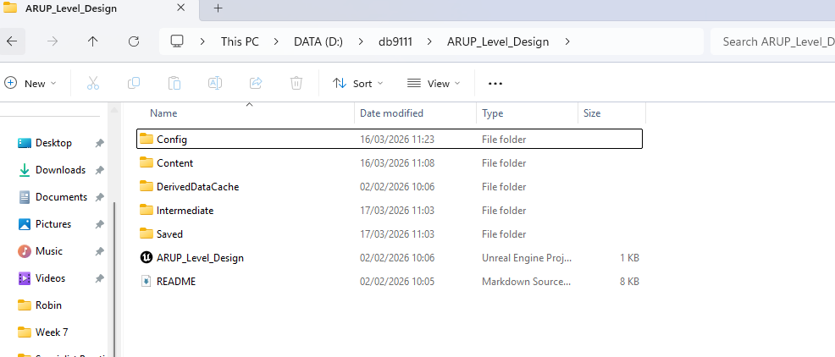

3. Open the terminal in that folder
Right click inside the folder and open:
- terminal / command prompt
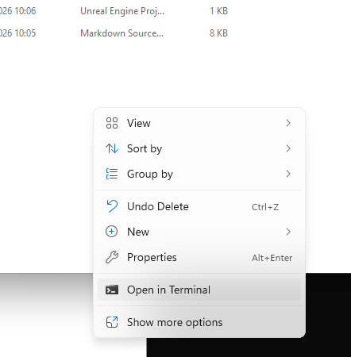

4. Initialise Git
Run:

5. Add the Unreal gitignore file from canvas
Week 10 Pre Session Material: Level Design and Rapid Game Prototyping (2025 MOD010303 TRI2 F01ARP)

6. Set up Git LFS
University computers should have it, but on your home PC, you might need to run

7. Track Unreal large file types with LFS
git lfs track "*.uasset"
git lfs track "*.umap"
git lfs track "*.fbx"
git lfs track "*.png"
git lfs track "*.jpg"
git lfs track "*.wav"
git lfs track "*.mp4"
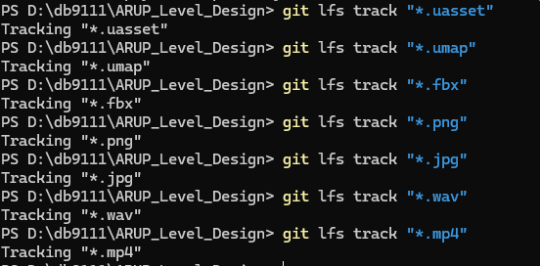

8. Check that .gitattributes exists
You should now have this file in your project folder:
.gitattributes

9. Add everything

10. Make your first commit
Run:

11. Link your local project to GitHub
Replace the URL with your own:

12. Rename branch to main

13. Push to GitHub

After that
Every time you want to upload changes:
git add .
git commit -m "Describe what you changed"
git push

